|  |
| --- |
| **Methods Draft ( Drafting Start : 2020.03.26 – 2020.04.##)** |

*The sections below detail processes & protocols for the Summer 2019 Krill Study. Narratives are broken into different sections to make drafting and edits easier. This document will be stored on the google OA Drive under experiments > krill> 04. 2019 > 04. 2019 Krill Project (Summer Conditions) > 12. Writing (Drafts). This document will be version control managed and every effort taken to maintain comment(s) from each participants.* 

|  |
| --- |
| **Methods Section (Version One – “Continuous Brevity”)**  PROs & CONs |

**Experimental system**

**The experiment was conducted at the NOAA Northwest Fishery Science Center’s Mukilteo Research Station in Mukilteo, WA, USA. The Mukilteo Research Station hosts an experimental system designed specifically to conduct studies to understand the sensitivity of marine species to OA, warming, and ocean deoxygenation, hereafter referred to as the experimental system. The experimental system contains 13 independent replicates, each with entirely independent control over treatment conditions. The systems operated on flowing seawater from Puget Sound which was filtered to 1 µm, UV sterilized, and maintained at 12°C. Prior to flow into each replicate, seawater was degassed. Each replicate then added carbon dioxide, oxygen, and nitrogen under real-time, data-driven feedback control system using Lab View Software (version needed) and Honeywell Durafet III pH (what type of pH scale) and Vernier optical dissolved oxygen probes Temperature was controlled by the software using Omega thermistors. Flow through the part of the system that maintained the krill was controlled with a solenoid valve, with an on-off setting.**

**Treatments**

**During the acclimation period (11 days), the experimental system was held at 11°C +/- 1°C and water chemistry was not manipulated (i.e., conditions reflected that of intake water). After the acclimation period, replicates were assigned to treatments in a way that balanced percent survival across treatments.**

**table (1A)**

**Chemistry**

**Probes in each replicate continuously recorded temperature, pH, and DO. Temperature probes were calibrated with a Fluke temperature probe, pH probes with Tris buffer, and DO probes with a PreSens optical oxygen Fitbox4 sensor and oxygen sensor spots (SP-PSt3-NAU-D5-YOP). Salinity was measured daily in each replicate with Honeywell UDA (model) . Each replicate was monitored weekly for pH and DO. pH conditions in each replicate were monitored via spectrophotometry using an Ocean Optics USB 230 2000+ Fiber Optic Spectometer and a 5mM solution of m-cresol purple indicator dye (Sigma Aldrich). DO conditions were monitored with the Presens systems. Discrete water samples for measurement of total alkalinity and DIC were taken X days after the beginning of the experiment and Y days after its end. These samples were analyzed at XXXX using standard operating procedures for all carbon chemistry analyses (Dickson et al 2007).**

**We used XXX and XXX measurements to estimate pCO2 with CO2sys version 2.1 [50], using the K1 and K2 constants from Lueker et al. [51], KHSO4 constant from Dickson [52], [B]T from Uppstrom [53], and the total pH scale.**

**Collection**

Adult *Euphausia pacifica* krillwere collected from Puget Sound off of Mukilteo, WA (47.982569, -122.307623 +/- .25nm) on September 9 and 10, 2019 between X pm and Y pm. To capture krill, a XXX net with 1500μm mesh was towed obliquely at X–Y knots at an approximate depth of 25 m for Z minutes. The contents of each tow were immediately transferred to a temperature-controlled, aerated holding tank and transported to the laboratory, where they were haphazardly sorted into the treatment system. The approximate time from collection to placement into the laboratory experimental system was 3-4 hours. No gravid females (based on ovary color) were included in the study, though just X were sited in the collected krill.

Husbandry

Krill were held under acclimation conditions for 11 days and treatment conditions for 35 days. They were housed in 44L aquaria inside each replicate experimental treatment at a density of 80 krill per replicate (1.8 krill/L; approximately 3 g krill per replicate). Everyday during night-time conditions when water did not flow to the vessels with krill, each replicate was fed 6.9 mL Instant Algae (Reed Mariculture Shellfish Diet 1800) or approximately 13.8 billion cells. Every three days, each replicate was given 0.44 mL EZ Larvae (Zeigler 250-600 micron Larvae Concentrate). Every four days, each replicate was given approximately 44,000 freshly hatched Artermia salina (San Francisco Bay) for a density of 1 nauplius per 1 mL. EZ Larvae and Artemia were added during the no-flow period.

Mortalities were assessed visually every day in each replicate as was the presence or absence of molts. Species identification was confirmed for each mortality via microscopy using a Nikon Microscope (SMZ715T) with Sony Camera (DFK 33UX226c) configured with Imaging Source Software (Company?, version?). Every four days, each aquarium was cleaned during the period of water flow using a siphon and sponge.

Respirometry

Respirometry trials occurred over the course of four, two hours rounds over a period of two days; recording animal’s respirometry rates during the “night” period. Selection of MOATs aquaria and corresponding animals was balanced against individual MOAT’s mortality (remaining biomass), treatments, spread across days of respirometry trials (2-days) and the rounds of trials (2-rounds) in a given day.

Lipid analysis

Ten hours after collection on September 10, 2019 four, ~100 mg samples of freshly caught krill were collected and flash frozen to reflect the lipid profile of wild krill (N≅3 krill per sample). These animals we held outside of the experimental system under temperature control and aeration, under starvation conditions.

Information here from Louise re methods

Statistics

Survival: At the end of the study, it was clear that not all mortalities were captured by visual assessment. We assumed that these mortalities were spread evenly (in whole numbers) across all days that krill were held in the lab.

.

|  |  |  |  |  |  |  |  |
| --- | --- | --- | --- | --- | --- | --- | --- |
| **Table #1A – Placeholder for Title (please note this draft table differs from protocol)** | | | | | | | |
| **Treatment Type** | **Target Temp** | **Target pH** | **Target DO** | **MOATs** | **pCO2** | **Hconc** | **% Sat DO** |
| Acclimation | 11 | 7.73 | 9.4 | All | 798.8425 | 18.62087 | 100 |
| Current Day | 11 | 7.64 | 5.6 | 03, 07, 10, 12 | 995.2630 | 22.90868 | 60 |
| Current Night | 12 | 7.73 | 9.2 | 802.7367 | 18.62087 | 100 |
| High Temp Day | 13 | 7.64 | 5.4 | 01, 06, 11 | 1411.3284 | 31.62278 | 60 |
| High Temp Night | 14 | 7.73 | 8.8 | 1198.4801 | 26.91535 | 100 |
| All Change Day | 13 | 7.50 | 4.5 | 02, 08, 13 | 1411.3284 | 31.62278 | 50 |
| All Change Night | 14 | 7.57 | 8.8 | 1198.4801 | 26.91535 | 100 |
| Ambient Day | 14 | 8.5 | 8.5 | 04, 05 | Atmospheric | Measured | 100 |
| Ambient Night | 11 | 8.5 | 8.5 | Atmospheric | Measured | 100 |
| Alkalinity- 1997.615 (standard used for measuring), Starting Salinity- 29.3 PSU | | | | | | | |

Time between respirometry trials, lipid preparation, and timing between day night cycles created differences in fasting periods among MOATs aquaria. Biomass and length of fasting period was recorded to allow (weighted) follow-on analyses of lipid composition across individuals and treatments. Animals, per MOATs, were added to individual cryovials after: (1) wet weight was measured and (2) species determination with microscopy using a NIKON Microscope (SMZ715T) with Sony Camera ((DFK 33UX226c) configured with Imaging Source Software until the goal 100mg of biomass was achieved per vial.

|  |
| --- |
| **Methods Broken into thematic sections below:** |

|  |
| --- |
|  |

|  |
| --- |
| **Animals and Collection** |

**Animals:**

Adult *Euphausia pacifica* krillwere collected from multiple sites in Puget Sound (47.982569, -122.307623 +/- .25nm) on 09SPE19 and 10SEP19 overnight via plankton tow net at an approximate depth of 25meters. The contents of each tow were immediately transferred from the cod end, to a 5-gallon bucket, and pooled into a 8.5 liter cooler with ice packs and air bubbler. Time in cooler on boat, transit to lab, and sorting while inside the lab lasted between 3-4hours.

**Collection**

Animals were collected on the nights of 09SEP19 and 10SEP19 with a 1500μm mess plankton net at an approximate depth of 25meters IVO 47.982569, -122.307623 between 2145-2130 local time.

**Transportation**

Euphausia pacifica were loaded into coolers between tows and while transported back to the lab. Time between collection and final sorting into aquaria lasted between 3-4 hours.

|  |
| --- |
| **Sorting** |

**Sorting**

Krill were loaded into all twelve Mobile Ocean Acidification Treatment System (MOATS) on a rolling basis. Sorting between all twelve MOATs ended at the same time.

Final count of all krill per MOATs was recorded as 85 in MOATs 01 and MOATs 02. MOATs 03-08: MOATs 10-13 had 80 krill per aquaria.

Researchers took care to sort only Euphausia pacifica and exclude pregnant female krill.

Animals were sorted to achieve a target density of 80 krill per independent MOAT System, allowing an estimated starting biomass of three grams of krill tissue per aquaria.

**Sorting Wild Krill For Lipids Analysis**

A portion of krill were not sorted into any of the twelve MOATS and left in a temperature control environmental chamber with bubbler for an 10hour fast. This “wild” cohort was prepped for lipids analysis directly follow the 10hour fast. Individuals from the wild cohort were selected, dried, weighed, and photographed and added to cryovials until each vials had at least 100mg. Four wild lipid samples were prepared across 13individuals.

|  |
| --- |
| Acclimation Period Information |

**Acclimation Period**

Prior to animals being under treatment they experienced a 12 day acclimation period. The acclimation period allowed a nine hour no flow period to allow krill to eat a varied diet consisting of the following inputs: 5.25mL of Instant Algae (Reed Mariculture, Shellfish Diet 1800), 5.72ml of EZ Larvae (Zeigler 250-600 micron Larvae Concentrate), and a ratio of 1 San Francisco Bay strain brine shrimp to 1mL of aquaria water (1:44,000). This amount of brine shrimp varied from hatch to hatch.

The MOATs were kept at a temperature of 10.5°C to 11°C. MOATs were slowly brought to their treatment conditions over a 72hour period.

|  |
| --- |
| Treatment Conditions & Water Chemistry |

Treatment Conditions

|  |  |  |  |  |  |  |  |  |
| --- | --- | --- | --- | --- | --- | --- | --- | --- |
| **Treatment Type** | **Temp** | **pH** | **DO** | **salinity** | **alkalinity** | **pCO2** | **Hconc** | **% Sat DO** |
| Acclimation | 11 | 7.73 | 9.4 | 29.3 | 1997.615 | 798.8425 | 18.62087 | 100 |
| Current Day | 11 | 7.64 | 5.6 | 29.3 | 1997.615 | 995.2630 | 22.90868 | 60 |
| Current Night | 12 | 7.73 | 9.2 | 29.3 | 1997.615 | 802.7367 | 18.62087 | 100 |
| High Temp Day | 13 | 7.64 | 5.4 | 29.3 | 1997.615 | 1411.3284 | 31.62278 | 60 |
| High Temp Night | 14 | 7.73 | 8.8 | 29.3 | 1997.615 | 1198.4801 | 26.91535 | 100 |
| All Change Day | 13 | 7.50 | 4.5 | 29.3 | 1997.615 | 1411.3284 | 31.62278 | 50 |
| All Change Night | 14 | 7.57 | 8.8 | 29.3 | 1997.615 | 1198.4801 | 26.91535 | 100 |
| Ambient Day | 14 | 8.5 | 8.5 | 29.3 | 1997.615 | #### | #### | 100 |
| Ambient Night | 11 | 8.5 | 8.5 | 29.3 | 1997.615 | #### | #### | 100 |

**Treatment Determination Between/Across MOATS**

Krill were divided into treatments based on percent survival with the goal of equity in survival across treatments.

MOATS were then divided as follows:

“All Change”: 02, 08, 13

“Hi- Temperature”: 01, 06, 11

“Current Conditions”: 03, 07, 10, 12

“Ambient”: 04, 05

Another Draft of the Treatments Table =

|  |  |  |  |  |  |  |  |
| --- | --- | --- | --- | --- | --- | --- | --- |
| **Treatment Type** | **Temp** | **pH** | **DO** | **MOATs** | **pCO2** | **Hconc** | **% Sat DO** |
| Acclimation | 11 | 7.73 | 9.4 | All | 798.8425 | 18.62087 | 100 |
| Current Day | 11 | 7.64 | 5.6 | 03, 07, 10, 12 | 995.2630 | 22.90868 | 60 |
| Current Night | 12 | 7.73 | 9.2 | 802.7367 | 18.62087 | 100 |
| High Temp Day | 13 | 7.64 | 5.4 | 01, 06, 11 | 1411.3284 | 31.62278 | 60 |
| High Temp Night | 14 | 7.73 | 8.8 | 1198.4801 | 26.91535 | 100 |
| All Change Day | 13 | 7.50 | 4.5 | 02, 08, 13 | 1411.3284 | 31.62278 | 50 |
| All Change Night | 14 | 7.57 | 8.8 | 1198.4801 | 26.91535 | 100 |
| Ambient Day | 14 | 8.5 | 8.5 | 04, 05 | Atmospheric | Measured | 100 |
| Ambient Night | 11 | 8.5 | 8.5 | Atmospheric | Measured | 100 |
| Alkalinity- 1997.615 (standard used for measuring), Starting Salinity- 29.3 PSU | | | | | | | |

|  |
| --- |
| Diet |

Diet remained constant both under treatment and during the initial 11 day acclimation period. Inputs varied between 24, 72, and 96hour intervals. On a 24hour basis the krill in each 44L MOATS aquaria was fed 5.25mL of Instant Algae (Reed Mariculture Shellfish Diet 1800). Every 72hours, MOATs were dosed with 5.72ml of EZ Larvae (Zeigler 250-600 micron Larvae Concentrate). Artermia salina (San Francisco Bay brand) were added every 96hours at a ratio of 1 nauplius per 1mL of aquaria water (1:44,000mL). All dietary inputs were added to each individual aquaria during the no-flow, night conditions period.

Artermia salina (San Francisco Bay brand) at a target concentration of 1 nauplius per mL

|  |
| --- |
| Cleaning and “Data production” |

**Cleaning**

Every 96hours aquaria were cleaned during the day conditions period to minimize disruption to target water chemistry. Detritus and krill carcasses were removed via siphoning after recording for mortality. Species determination was confirmed via microscopy using a NIKON Microscope (SMZ715T) with Sony Camera ((DFK 33UX226c) configured with Imaging Source Software. After photographing, the telson was measured.

**Observation Period / Accounting for (Density Dependent) Cannibalism**

Animals were sorted to achieve a target density of 80 krill per independent MOAT System, allowing an estimated starting biomass of three grams of krill tissue per aquaria. MOATs were cleaned and animals observed in reoccurring 96hour intervals during the “day, flow period” to minimize animal handling, water loss, and stress. Carcasses collected during cleaning were used to create a survival rate. Incomplete carcasses with a majority of its segmented abdomen intact were including in the mortality count but not disconnected eye stalks, rostrums, and antenna.

This lead to mismatch between observed and expected number of surviving krill. Researches took the difference between observed and expected and calculated an Δ Observation Period (ΔOP) per MOATs. This ΔOP was rounded to the nearest whole integer and fit along the survival curve.

ΔOP was incorporated into the mortality data to fit along the survival curve.

ΔOP was incorporated into the mortality data as to best resemble the overall observed mortality rate.

ΔOP was attributed to the beginning of the study as to be best incorporated with the overall observed mortality data.

The steepest section of the mortality curve occurred in the first three weeks of the project. It is most likely that the ΔOP would occur during this time either due to cannibalism or missed by observers with the volume of other mortality events.

**End of Project** – Actions Taken- Walk the reader through respirometry and lipids prep

Animals were under treatment for (35days, 5weeks, 840hours). Following the fourth week of the experiment animals were subsampled for respirometry trials. All krill remaining at project’s end were flash frozen and prepared for lipids analysis.

Respirometry trials occurred over the course of four, two hours rounds over a period of two days; recording animal’s respirometry rates during the “night” period. Selection of MOATs aquaria and corresponding animals was balanced against individual MOAT’s mortality (remaining biomass), treatments, spread acorss days of respirometry trials (2-days) and the rounds of trials (2-rounds) in a given day.

24hours prior to respirometry trials MOATS aquaria were siphoned cleaned to achieve a 24hour fast.

Animals not selected for respirometry were also prepared for follow-on lipids analysis, all animals experienced a fasting period.

All animals/krill/*Euphausia pacifica* were prepared for lipids analysis with at least a 24hour fast. Time between respirometry trials, lipid preparation, and timing between day night cycles created differences in fasting periods among MOATs aquaria. Biomass and length of fasting period was recorded to allow (weighted) follow-on analyses of lipid composition across individuals and treatments. Animals, per MOATs, were added to individual cryovials after: (1) wet weight was measured and (2) species determination with microscopy using a NIKON Microscope (SMZ715T) with Sony Camera ((DFK 33UX226c) configured with Imaging Source Software until the goal 100mg of biomass was achieved per vial.

This resulted in 3-5 *Euphausia pacifica* per vial.

|  |
| --- |
| Casualty Response(s) throughout the project (talking about the “winter-storm” event) |

Casualty Response(s) throughout the project (insert)

Dropping MOATS 11, MOATs 02, MOATs 06

System Causalities-

Project began with three treatments and 12 MOATS assemblies, allowing four replicated per treatment. Certain MOATs assemblies were not included in respirometry trials and/or prepared for lipids analysis prep due to system causalities.

MOATs 04 and 05 faulty thermistors never allowed the MOATS to come to treatment following the 72hour ramp. These two MOATs assembly remained inside the project but proceeded without temperature or chemistry control. Flow control remained in-effect to allow for a feeding, no-flow period.

A pH probe failure in MOATS Assembly 11 delivered a pH of 5.5 to 6.0. The dosing period was acute but resulted in extreme mortality.

A data feedback failure occurred on 04OCT19 in MOATs 03, allowing the aquaria temperature to extend tolerance and was dropped from the study.

A late fall storm event occurred between 18-19OCT placing increased sediment and stain on system filters. Supply water lagged behind pump and allowed water in the “bubble-box/gas delivery box” to drop. The drop in the level of water inside the bubble-box allowed the small heating element to bleed through the gas delivery tubing. This affected all MOATs to greater and lessening degrees.

|  |
| --- |
| Supporting Documents – Recap of the 2019 Summer Study Protocol |

1. **Pre-Krill Introduction**

The following section describes the conditions inside the lab before the krill were introduced. For the Summer Krill Study of 2019 this represented the time frame between 01SEP19-09SEP19. First collection day was 09SEP19.

**1.1.a MOATs Pre-Step Up** (conditions to meet before adding animals). Krill were placed into MOATs with an average temperature of 11.2°C.

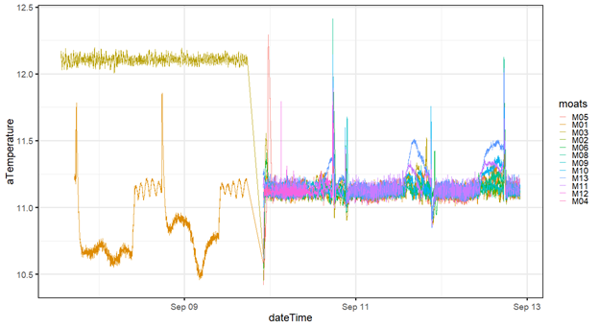

**Figure 1.1.a Lab Introduction Conditions for Summer Krill 2019**

**1.1.b System Monitoring.** Krill were added to the MOATs when communication alarms were tested on all MOATs and MOATs 09 provided temperature, pH, and dissolved oxygen alarms.

**1.1.c. Starting Water Chemistry.** Different amounts of water for artemia and buffers inside of the “Instant Algae” (IA) were a concern for maintaining treatment conditions. No appreciable difference was found with the introduction of dietary inputs. If the ratio changes of 5.25mL of IA, 5mL of Easy Larva, and ~120mL of Artemia to the 44L acrylic animal box then test again frequently to determine water chemistry reactions. Respiration with high box density is a factor to consider when trying to dial in water chemistry.

**2.0 Collection**

The following section details how krill were collected for the Summer Krill Study 2019. The ideal tow consists of deploying the plankton net at a depth of 25m, for a duration of 5minutes, at a speed of no greater than 2-3knots. The ideal krill size for this experiment is approximately .0250grams to .0450grams. This size determines target density ranging from 90/MOAT to 1080 across 12 MOATS. Getting to the correct target density, target biomass will determine the number of tows and the number of collection nights. Important that as krill are collected a number (12-48 Krill) are set aside for a wild krill lipids analysis, this only happened the second night of collection.

**2.1.a Dynamic Conditions & Towing Results**.

**2.1.1.a** Krill were collected the evenings of September 9th and 10th. September 9th, 2019 evening low tide, slack water, occurred at 2046. Nautical Twilight concluded at 2022, with Civil Twilight concluding at 1955. Sunset happened at 1932. Boat was launched at 1940. Boat on-station IVO 47.982569, -122.307623 at approximately 2030.  50meters of cable scope was deployed at a speed of 1.5-2knots to achieve a towing depth of approximately 25meters. Five of ten tows produced suitable sized krill ( x>.0250, x<.0650).

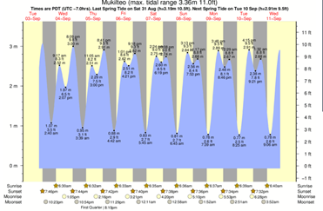

**Figure 2.1.a Towing Conditions for Summer Krill 2019**

**2.1.1.b** There had been a large storm event with plenty of algae and debris on the shore. This made it difficult to launch the boat and trailer due to poor tire traction but also appears to have been a contributing factor to the small amount of Krill harvested. Krill did not appear at expected depth or abundance.

**2.1.1.c** September 10th, , 2019 evening low tide, slack water, occurred at 2121. Nautical Twilight concluded at 2021, with Civil Twilight concluding at 1954. Sunset happened at 1931. Boat was launched at 2015. Boat on-station IVO 47.982569, -122.307623 at approximately 2100.

**2.1.b CTD Casting.** Water column profile data was collected by means of a conductivity, temperature, and depth logger (CastAway CTD P/N 400313-01 Rev C). This water column profile (<https://drive.google.com/open?id=1Tq1tS9UoihpKAhkr0DRtr9fMb3XPCJkg> ) was used to help inform and corroborate (buoy information) to complete the “Current Conditions” treatment environment inside the perspective MOATS.

**2.1.1 CTD Casting Instructions.** To start the cast use the lower left button to select the Cast-CTD function, press the lower right button to start the GPS and record location. Wait for the green light or press the lower right button to begin.

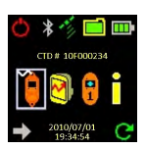

**Figure 2.1.1 CTD Start Icon Selection**

**2.1.2 CTD GPS Lock.** The first GPS lock of the day or after installing batteries can take 4 to 10 minutes. Limited GPS reception may increase wait time.

.

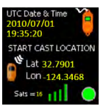

**Figure 2.1.2 CTD GPS Lock Indications**

**2.1.3 CTD Recording.** This screen verifies that your CastAway CTD is recording data and is ready to cast. The screen will go blank but the LED will continue to blink while recording.

. 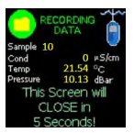

**Figure 2.1.3 CTD Recording Data Indications**

**2.2.a Sorting.** Travel time inside cooler on-boat, then trailer, and into the lab lasted an approximate 45minutes. 09SEP19 25-krill were stocked between moats. 10SEP19 60 to 65-krill were stocked between MOATs to bring the project start totals to the MOATs as follows:

MOATs 01- 85 | MOATs 02- 85 | MOATs 03- 80 | MOATs 04- 80 |

MOATs 05- 80 | MOATs 06- 80 | MOATs 07- 80 | MOATs 08- 80 |

MOATs 10- 80 | MOATs 11- 80 | MOATs 12- 80 | MOATs 13- 80

**2.2.1.a** Gravid female krill were removed. Note that krill would not identified by species until examined upon mortality analysis, used for project’s end respirometry, and/or prepared for lipids analysis.

**2.2.b Treatment Determination.** Krill Treatment Determinations were made approximately on 19SEP19 and confirmed on 24SEP19 with the introduction of the ambient treatment. Krill were divided into treatments based on percent survival with the goal of equity in survival across treatments. When reviewing “Ramp Success” between 09-22-19 to 09-23-19  MOATs 04 and MOAT05 did not come to treatment and a fourth treatment was created, “Ambient”.

MOATS were then divided as follows:

“All Change”: 02, 08, 13

“Hi- Temperature”: 01, 06, 11

“Current Conditions”: 03, 07, 10, 12

“Ambient”: 04, 05

**2.3.a Aquaria Acclimation.** Krill’s circadian rhythm was slowly modified to allow night time no flow, sampling, and feeding period happened at night.

10SEP19 Flow Period (undetermined)

11SEP19 Flow Period 2101-1359 (17hrs), No Flow Period 1400-2100 (7hrs)

12SEP19 Flow Period 1030-1730 (7hrs), No Flow Period 1731-1029 (17hrs) *First big flip

13SEP19 Flow Period 2101-1159 (15hrs), No Flow Period 1200-2100 (9hrs)

20SEP19 at 2100 ramp conditions begin over a 72hour period, bringing MOATs to respective treatment levels.

**2.4.a Wild Lipids Collection.** Krill were placed into the MOATs with an average temperature of 11.2°C. Wild krill (<https://drive.google.com/open?id=1PfWFP_9ZL2iEncFJuBaBKzo1djh-Z2_K> ) their weights were recorded, photographed, and telsons’ measured

(<https://drive.google.com/open?id=1_fVyinljlZk3ToDT2W1-0Vr80L8TunLu> )

**2.4.1a.** On September 9th, 2019 2 liters of sea water and collected Krill were not first put aside for lipids analysis. Team members began sorting directly once back at the lab. After 2-3 hours of sorting it became apparent that only smaller krill (presumed to weigh less than .0250grams) remained in coolers. Team members then chose not to spoon Krill out of the MOATs to hold for Lipids Analysis that following day.

**2.4.1.b** All wild lipids analysis were taken from Krill collected during Day 2, September 10th, 2019 and processed on September 11th, 2019. Photos and measurements saved to google drive<https://drive.google.com/open?id=1PfWFP_9ZL2iEncFJuBaBKzo1djh-Z2_K>. Photos names were generated with the data and sequence of the krill processed to create the krill ID.

1. **Krill Husbandry**

Krill Husbandry Overview- on Mondays and Thursdays the krill boxes were especially checked with the number of mortalities and molt presence. Species ID, gender, and telson length of each mortality in each MOAT were recorded. If there isn’t time to species ID, sex, and measure each krill, the krill were placed into 6-well wellplates in individual wells and preserved with 95% ethanol. The wellplate was labeled with the date and the MOATs number for later examination. This happened on two occasions throughout the study. Krill were in general, examined in detailed every sampling day.

**3.1.1 Feeding.** All krill will need to be fed daily with a solution of Instant Algae manually. Additionally, they will be fed every 3-4 days with artemia (Tuesdays and Fridays) and EZ Larvae (Mondays and Thursdays).  Target feeding time at or just after 10:30 am, when the flow will turn off**.**

**3.1.1a Instant Algae and EZ Larvae**: The solutions will need to be made with filtered seawater from one of the control treatment MOATS. The calculations below assume that 13 MOATS are(were) used in the experiment. See [here](https://docs.google.com/spreadsheets/d/14xKxKBfpuwsQ-6gZj97TTe0voJBW68C95OES4q6vxr8/edit#gid=1689143936) for calculation details.

**3.1.2 Instant Algae:** Measure out 120 mL seawater and pour into to a small beaker. Add 6.9 mL Instant Algae (bottle in the fridge in artemia room) to the seawater. This will need to be sieved through a 20um screen. The solution will be thick and won’t sieve on its own. Add 5.25 ml to each moat every day. Put any unused solution in the fridge in the Artemia room

**3.1.3. EZ Larvae:** Measure out 59 mL seawater and pour into a small beaker. Measure out 5.72 mL EZ Larvae (bottle in the fridge in artemia room) using a small graduated cylinder and a funnel, and add to the seawater. Make sure to mix solution due to the solution clumping. Added 5 ml to each MOAT on Mondays and Thursdays.

**3.1.4 Artemia**: Turn off air flow to artemia and let sit 5 minutes. Drain using 63 um sieve and concentrate into a small beaker (about 1L-1600mL). Add a bubbler to keep things aerated and well mixed. Put 1mL samples into 3 wells of a 6-well plate. If the artemia are highly concentrated, you can pull out 0.5 mL and double your count for each well. Put the plate under the dissecting scope and use the handheld counter to get a count of the number of artemia in each well. Average of the three was taken and then divided the average into 44,000 (this is how many milliliters are in each krill tank). This number will give the final amount of artemia solution to add to each MOATS. Assuming a good hatch, two cone’s worth of ½ TBSP artemia cysts was typically provide enough artemia for all the MOATS. The krill box is approximately 42 liters. This can vary up to 44 liters depending on clogged the screen on the front left-hand side of the Krill box. Scrub the mesh every sampling day to break up the artemia cyst and artemia-mort accumulation.

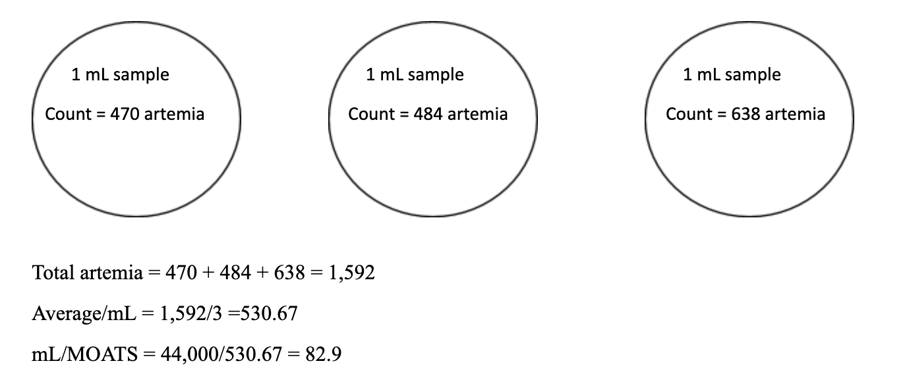

**Figure 3.1.4 Artemia Concentration Preparation Example.**

**3.1.4a Artemia Strategies.** Helpful during artemia feeding days is to use the 250mL jars to ready the individual MOATs prescribed volume of artemia. Keep the bubbler inside the large beaker as you pour out the “artemia solution” for concentration uniformity

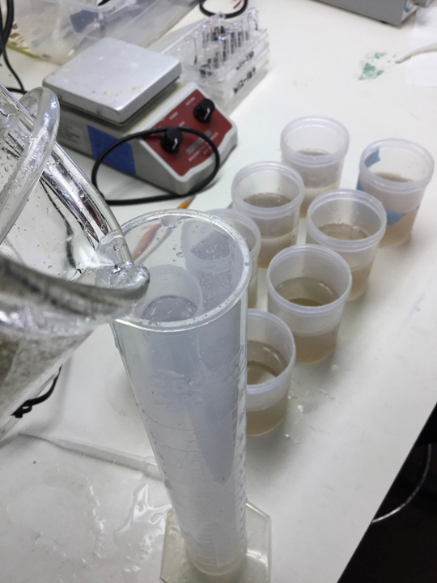

**Figure 3.1.4a Artemia Preparation Example with 250mL jars.**

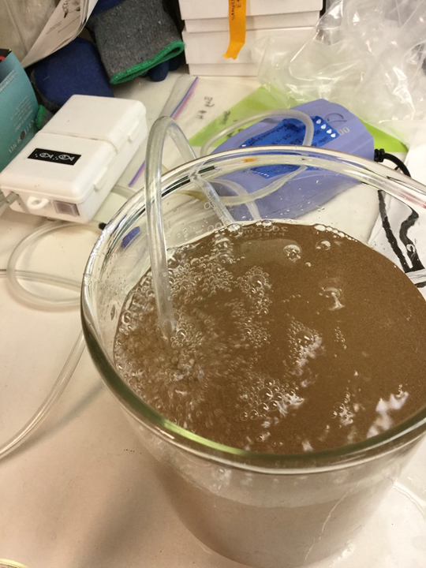

**Figure 3.1.4b Artemia Preparation with Bubbler remaining in Beaker.**

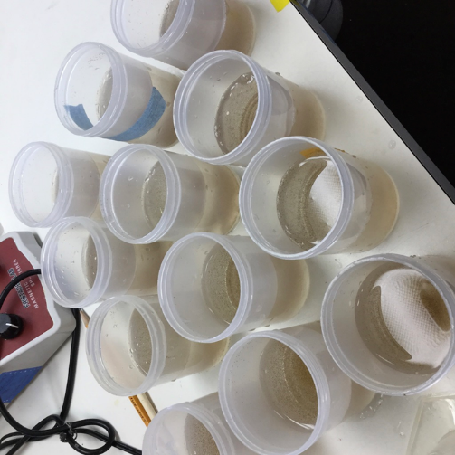

**Figure 3.1.4c Artemia Preparation distributed into 250mL jars.**

**3.1.5 Food Storage.** Food was not always prepared and feed the same day. Batches made ahead of time didn’t exceed 7days. Food made ahead of time didn’t stay in the refrigerator for more than a week.

**3.1.1 Sampling and Cleaning.** In general, on Mondays and Thursdays researcher(s) check(ed) and record(ed) the number of mortalities and record whether or not you observe molts. From the wild krill weights, Krill were large enough to sample twice a week on  Monday and Tuesdays.

**3.1.1a Siphon Clean**. “Morts” were collected while siphoning during cleaning. The entire acrylic animal box was checked for  morts since some would remain along the water line and others remained on the bottom. Team members checked the acrylic box and siphoned water samples for morts and molts. Molt presence was indicated as either yes, no; present, not present.  Morts were temporarily stored in 250mL jars before being collected into individual wells of a 6-well well-plate. While divided between MOATs in the well-plates the mort was photographed, species ID’ed, and measured. *Early in experiment legs/exopods were photographed in detail in attempt to make sex determinations.*

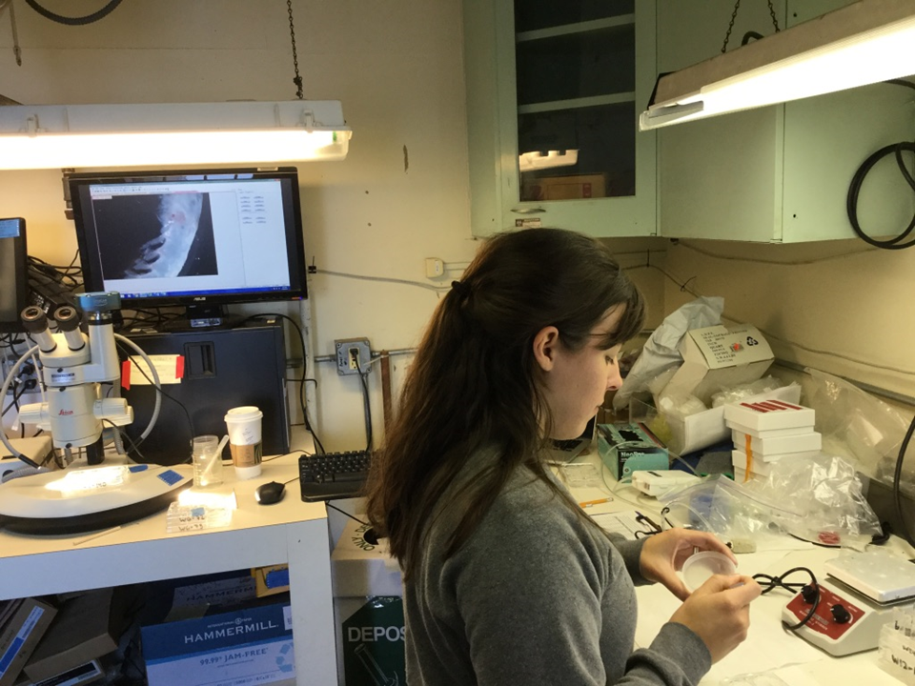

**Figure 3.1.1a MORT Analysis**

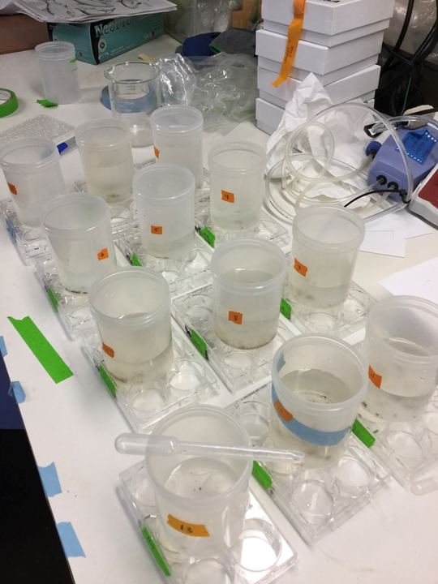

**Figure 3.1.1b MORT Analysis, Sampling in 6-Well, Wellplates**

**3.1.1b. Analysis with Morts.** Gender determination was attempted during every observation period but no sexually mature males were observed. Sex was not included as part of the end of the study experiment due to inability to identify genders. All observed krill were found to be Euphausia pacifica at every part of the study. MORTs were found in various stages of decay. For uniformity carcasses with the most intact tails were recorded as a MORT and counted. Datasheets would record species as N/A since rostrum to eyeball ratio couldn’t be characterized. When telson’s were damaged a score of N/A was given.

*Link to datasheets on morts.*

[*https://drive.google.com/open?id=12i4Im3GBM6g9361RBGFEzXVXqtx9ESNU*](https://drive.google.com/open?id=12i4Im3GBM6g9361RBGFEzXVXqtx9ESNU)

**3.1.1c Photography and Processing**. Measurements and pictures were taken with two different sets of computers/cameras/software and microscopes as better equipment and software became available. First Camera Assembly (Dates of use 09-11-19 to 09-26-19) LEICA MZ 75 microscope with OPTIX Cam Summit Series Camera with OPTIX CAM OC View Software package to photograph and measure krill. Second Camera Assembly (Dates of use 09-30-19 to 10-30-19) NIKON SMZ715T with Sony Camera manufactured by Imaging Source (DFK 33UX226c) and IC capture and measure software packages to photograph and measure krill.  Both were calibrated to the 10mm slide and no discernable difference  was found when MORTs were compared under both by comparing telson measurements of individual krill.

**3.1.1d Cleaning Concerns Throughout Study.** If possible, do the cleaning before the water flow turns off, but most likely you won’t be removing too much water from the system. Make sure the lights are off and you have the red flashlight handy. Remove the lid of the MOATS and move the tube connected to the auto-pipette along the bottom of the box, sucking up old food, dead krill, and molts. Keep an eye on the pipette so it doesn’t flood. Make as many sweeps as necessary along the bottom, dumping the contents of the tube into a beaker or bucket. Once you’re satisfied that the MOATS is clean enough, replace the lid and examine the contents in the light. Note how many dead you find and whether or not molts are present. Transfer dead krill into a 6 well plate to be examined under the microscope, photographed, sexed, and measured. If there’s not enough time to examine them that day, preserve them to be studied at a later date. After they’ve been photographed, the dead krill can be discarded. After siphoning is complete and no dead krill are visible in the tank, wipe down the sides of the tank with a sponge or cloth to break up any bacterial growth on the walls and floor of the tank.

**3.1.1e Mortality Estimates & Data Entry.** Mortality information needs to be entered every sampling day so that we know when enough krill have died to end the experiment. .

**3.1.2 Acclimation Period.** Prior to the observation period while animals are under treatment, they will experience a 12 to13 day aquaria acclamation period at ambient conditions. Feeding, cleaning, and sampling will continue along the experiment timetable with the exception of dissolved oxygen sampling.  First DIC samples will be 24hrs after one complete cycle of day and night conditions at treatment.

1. **Chemistry Variables**
   1. **Variables (Tolerances) & Sampling Regime**

|  |  |  |  |  |  |  |  |
| --- | --- | --- | --- | --- | --- | --- | --- |
|  | Sunday | Monday | Tuesday | Wednesday | Thursday | Friday | Saturday |
| Before 10:00 |  | Check morts & molts |  |  | Check morts & molts | pH samples |  |
|  |  | Clean tanks |  |  | Clean tanks |  |  |
|  |  | Start Artemia |  |  | Start Artemia |  |  |
| At 12:30 | Instant Algae | Instant Algae | Instant Algae | Instant Algae | Instant Algae | Instant Algae | Instant Algae |
| After 12:30 |  | EZ Larvae |  |  | EZ Larvae | Feed Artemia |  |
|  |  |  |  |  |  |  |  |
|  |  |  | Feed Artemia |  |  |  |  |
| Whenever |  | Process sp. ID/sex/size samples | Process sp. ID/sex/size samples | Process sp. ID/sex/size samples | Process sp. ID/sex/size samples | Process sp. ID/sex/size samples |  |
|  |  |  |  |  |  |  |  |
| Sampling | | | | | | | |
| Morning Samples period before 10:30 | n/a | Low Do Samples  (1/2 of MOATs) | Current & Ambient Conditions pH samples | Low Do Samples  (1/2 of MOATs) | High Temp Conditions pH samples | Make up if needed ** (DO)  All Change pH samples | n/a |
| Work Day Ramp Period 10:00-12:30 | n/a | n/a | n/a | n/a | n/a | n/a | n/a |
| Afternoon Samples- after 12:30 | n/a | High DO Samples  (1/2 of MOATs) | Current & Ambient Conditions pH samples | High DO Samples  (1/2 of MOATs) | High Temp Conditions pH samples | Make up if needed **(DO)  All Change pH samples | n/a |
|  |  |  |  |  |  |  |  |

**Table 4.1 Sampling and Feeding Regime**

**4.1.1 DIC sampling – Start.** 2 DIC samples from each treatment will be taken at the beginning and the end of the experiment.

**4.1.2 Acclimation Period Sampling.** Team memberssampled throughout the acclimation period to confirm what the krill are experiencing against the probes.

**4.1.3 Water Chemistry**- **pH.** As the pH in each MOAT will be different during the “day” period and the “night” period, samples will need to be taken to confirm the two pH conditions for each treatment.

**4.1.3a Double shot**. Characterized, this wasn’t discussed as to the periodicity and wasn’t considered till close to the end of the project, 24OCT19.

**4.1.3b History of pH spikes (High and Low)**. Figures detail problems and decisions made between 09SEP19-30OCT19. 26SEP19 MOATs 11 experienced significant low pH spikes and was dropped from the study. MORTs were still removed and animals were still fed so that MOATs 11 population could be used for process determination studies.

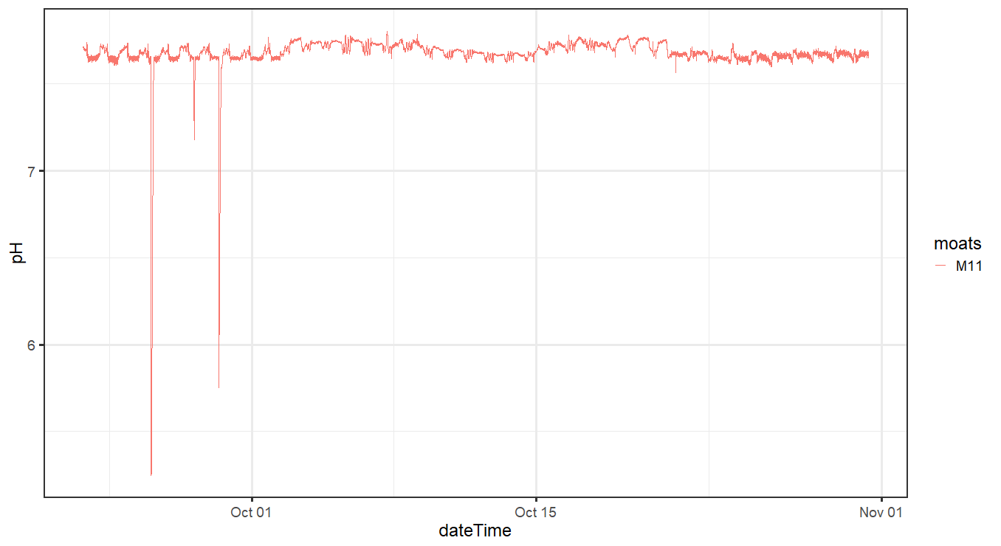

**Figure 4.1.3b 26SEP19 pH Spike in MOATs 11, impact on High Temperature Treatments**

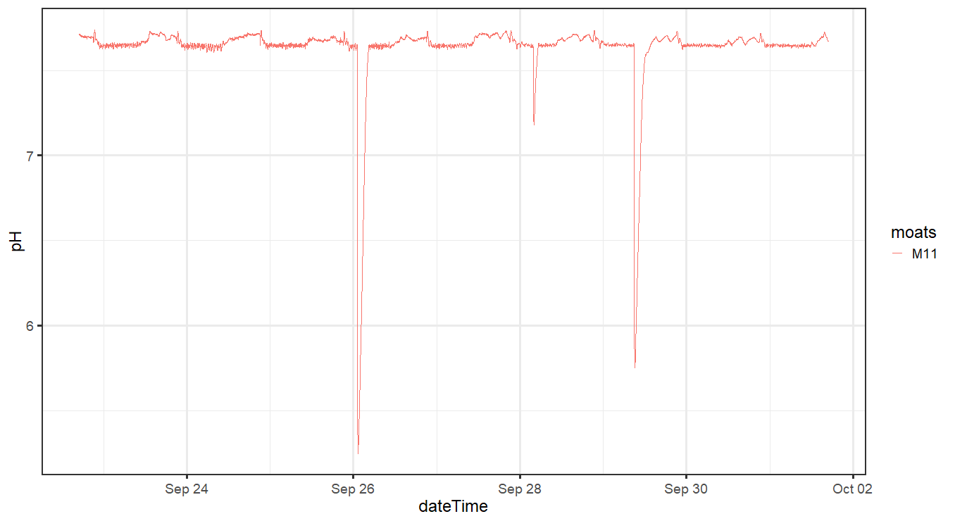

**Figure 4.1.3c 26SEP19 pH Spike in MOATs 11- Three Spikes**

**4.1.3.d Winter Storm Event.** The weekend of 19-20OCT saw a drop in water volume of the bubble boxes, troubleshot to clogged filtered. This fault was a cascade of problems for DO, pH, and temperature. MOATs 03 was dropped from the study on 24OCT19 primarily a high temperature spike, pH did drop below treatment. This impacted the respirometry samples for Day 1, 28OCT19. MOATs 12 had two rounds of respirometry that day.

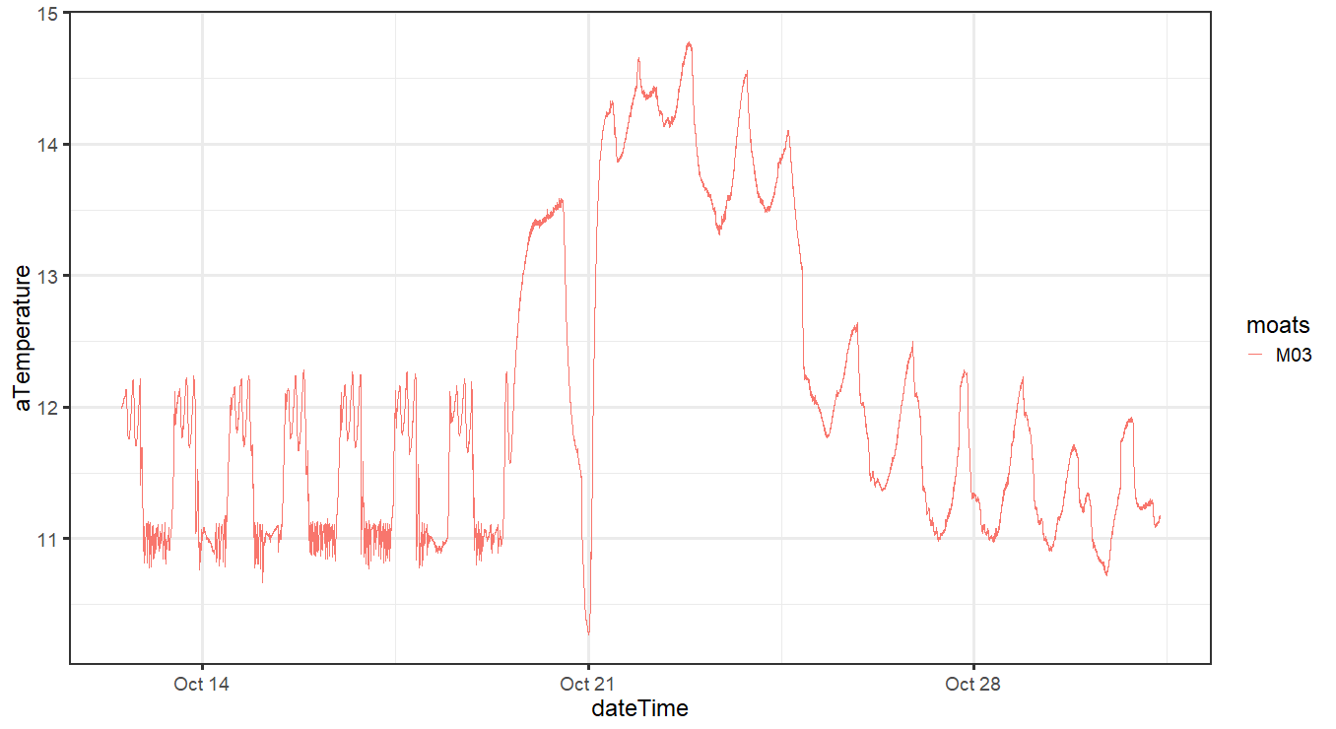

**Figure 4.1.3d 19OCT19 Temperature effects Following the “Winter Storm Event”**

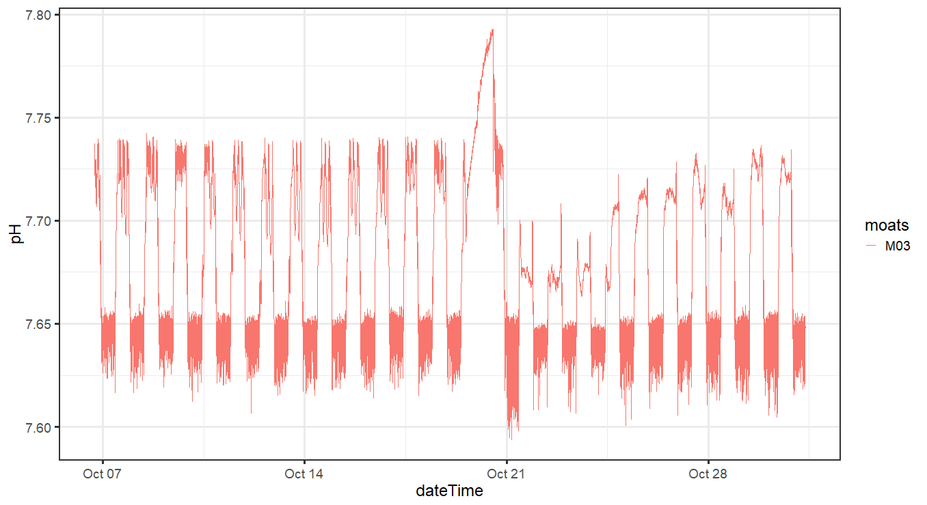

**Figure 4.1.3f 19OCT19 pH effects Following the “Winter Storm Event”**

**4.1.4 Water Chemistry**- **Dissolves Oxygen.** During acclimation period, take DO samples from each MOATS once a week. After the MOATS have reached their treatment levels, two samples need to be taken from each MOAT every week.  As the DO in each MOAT will be different during the “day” period and the “night” period, samples will need to be taken to confirm the two DO conditions for each treatment. 30SEP19 started sampling from the animal box. The week of 23SEP19 the SPEC code was being finalized and I really visualized the data. When I looked at the night time values, I wanted to explain the noise in the night time pH. I though the feeding krill might be driving down the pH with respiration. I only started comparing the lower box/jacket water to the animal box as of that date.  Multiple samplings occurred the week of 30SEP19 following the 01OCT19 lab meeting. By 07OCT we moved to sampling only from the animal box with the PRESEN and used the DO probe for comparison.  Mixing inside the acrylic box is important 4-5inches of PVC pipe was added to input connection elbow. It was determined that the ramp period was not long enough and the flow period was pushed back to 1230 from 1200. This was programed on 04OCT19 and first experienced by the krill on 05OCT19.

**5.0 Determining Factors for Project End**

**5.1.1 Goals.** Our goal is to have 4 lipid samples from each MOAT at the end of the study.  We need to get a sense of the weight range of the krill we get for the study before we can determine how many krill we need to get a minimum 100mg samples.  If the krill are the same size we worked with last fall, then we would need 2-4 to get to this mass. If they are the size we got in early August, we’ll likely need almost 20 krill to reach this goal.

**5.1.1a Biomass Determinations**. End of the Study was/is biomass dependent to be able to accomplish Lipid analysis preparation and an appropriate number of krill remaining for respirometry.

**5.1.2 Krill Doctrine**

1. Krill need to fast for 24hours prior to respirometry and lipids analysis preparation
2. Choose MOATs with the lowest number of animals remaining for the first round(s) of respirometry and follow on preparation for lipids analysis
3. Balance between MOATs across days of respirometry*
4. Balance between Treatments when choosing which respirometry round
5. Must achieve 4 vials per MOATs
6. Achieve 15-20 animals across treatments for respirometry
7. Wait until Night Time Conditions begin for the Krill to start Respirometry Trials

Example of How the Krill Doctrine was applied to the Loading Plan, Version 1

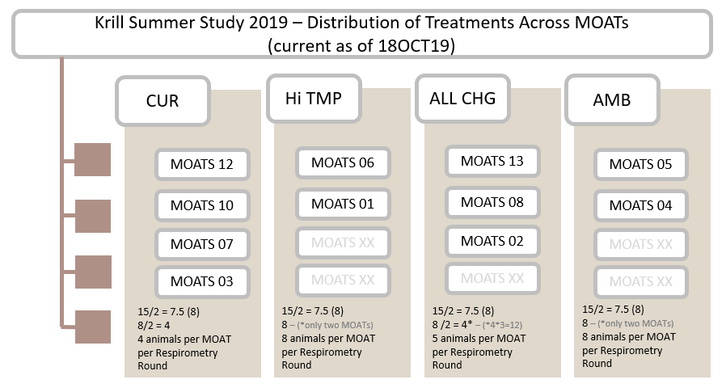

**Figure 5.1.2 Application of Krill Doctrine & Distribution of Treatments**

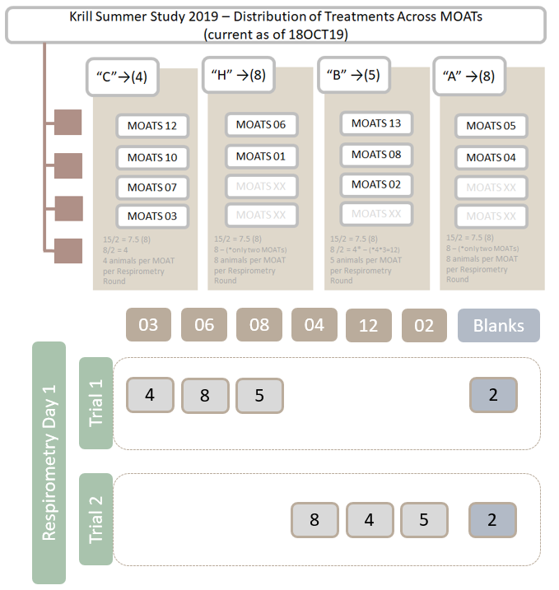

**Figure 5.1.2a Application of Krill Doctrine in Creation of a Loading Plan**

**5.1.2a. Working Through the Loading Plan**. Assuming you have at least ten MOATs still functions across a spread of treatments and the krill weight is still, on average, in excess of .0250 grams than 30 krill per box is about the minimum number of krill. To determine krill weight- measure the mass of whole MORTs during sampling days. MORT weights were measured starting on 29SEP19. I would subsample up to four MORTs at a time and take an average. As the study progressed and the mortality curve began to level off- this became more difficult as not all MOATs had MORTs present during sampling days and often no whole MORTs were available.

**5.1.3 End of the Experiment Prerequisite Tasks**. Mortality information needs to be entered every sampling day so that we know when enough krill have died to end the experiment. Biomass remaining determines project’s length.  We’ll need to make this call the day of so that we can start the food restriction appropriately on the MOATS that we will sample the following day. This day, the krill from the MOATS that will be sampled the following day SHOULD get algae during the no-flow period, but should NOT get EZ Larvae. Any EZ Larvae and Artemia remaining at the end of the no-flow period should be vacuumed up (if that seems feasible). The krill from the MOATS that will be “ended” two days later should get EZ Larvae and algae on the sampling day, and algae but not Artemia the next day. The spots will need to be calibrated the last sampling day, which is the day before the respirometry will begin.  The following outlines how that guidance was accomplished in the days leading up to the end of the experiment:

**15OCT19** Krill Study determined to end on 23-24OCT19 with 25OCT19 as a make up day.

**18SEP19** Loading plan and process, draft 1 submitted

**18-19SEP19** Winter Storm Event occurred,

**21SEP19** DO samples look especially high, further investigation leads to flow problems over weekend.

**21SEP19** Load plan and process draft 2 submitted when we decided to modify Krill Doctrine, Rule 3 since feeding and fasting requirements would have stretched the experiment to four days, held off on making a call and decided to wait 24hours to look for indications the situation was improving.

Krill sampled and fed per routine

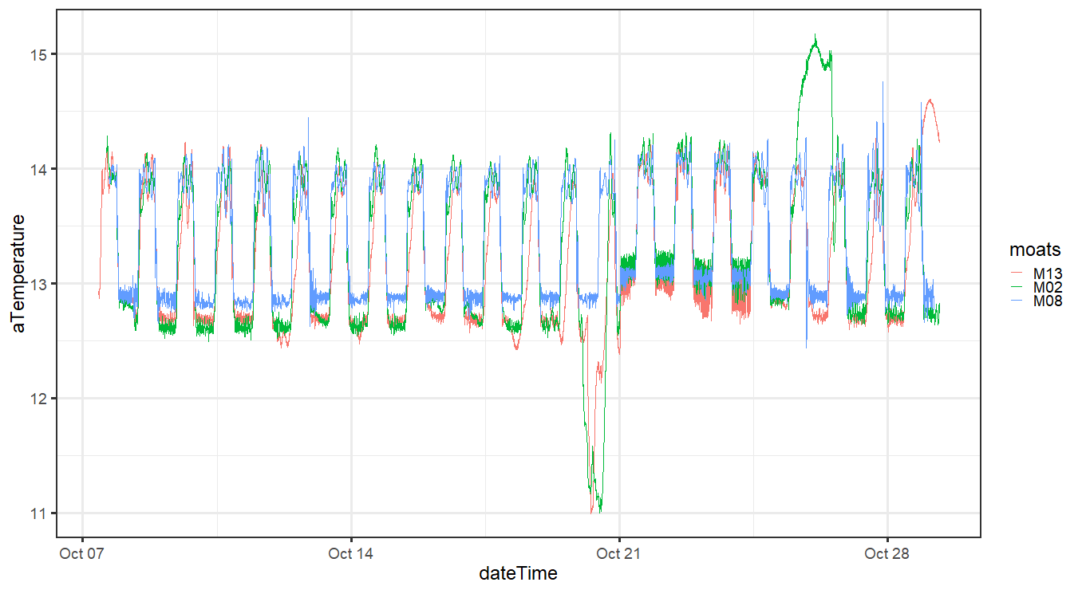

**Figure 5.1.3a “Winter Storm Event” Temperature Impacts- System Temperature. (MOATs 13, 08, 02)**

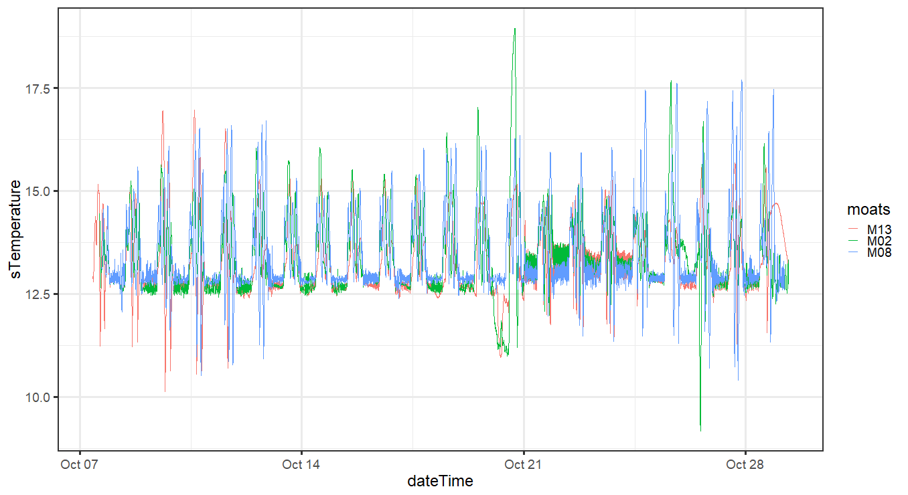

**Figure 5.1.3b “Winter Storm Event” Temperature Impacts- Animal Box Temperature**

**(MOATs 13, 08, 02)**

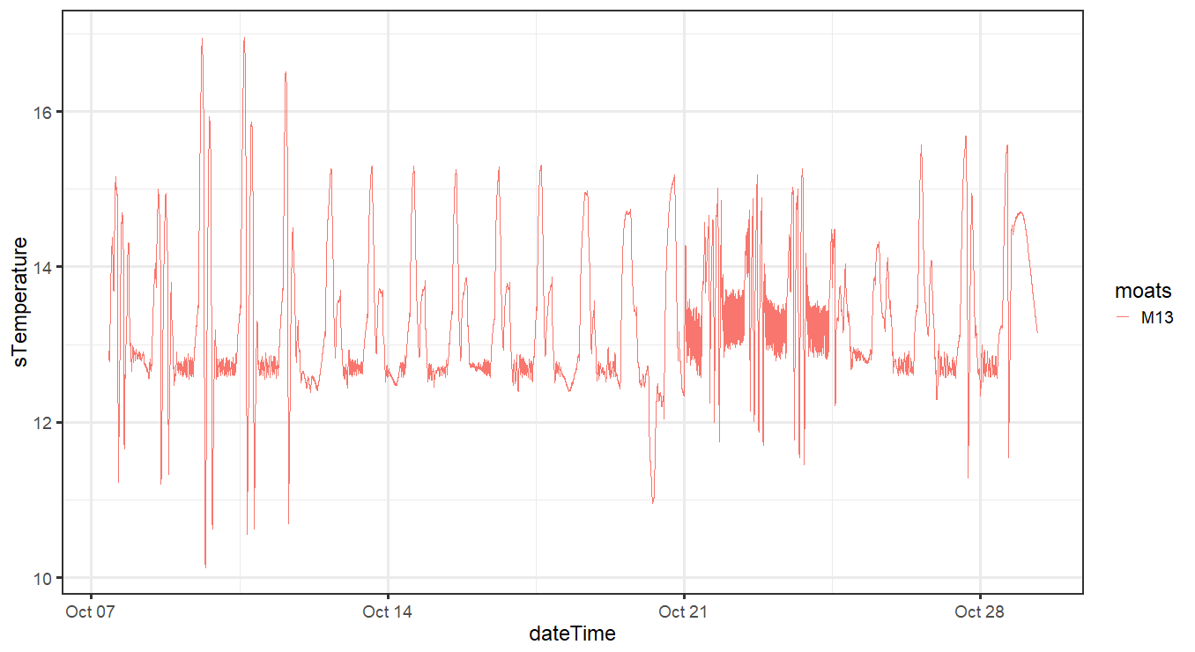

**Figure 5.1.3c “Winter Storm Event” Temperature Impacts- Animal Box Temperature (MOATs 13)**

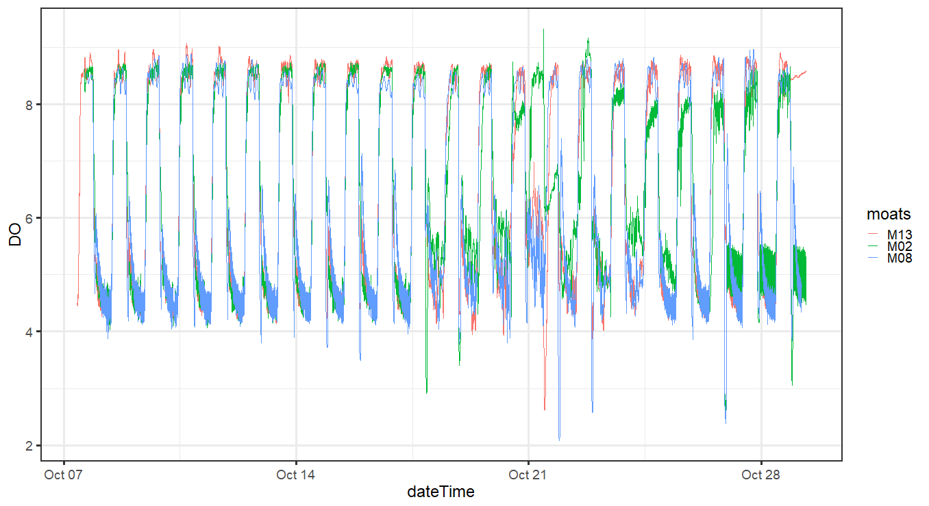

**Figure 5.1.3d “Winter Storm Event” Temperature Impacts- DO (MOATs 13, 08, 02)**

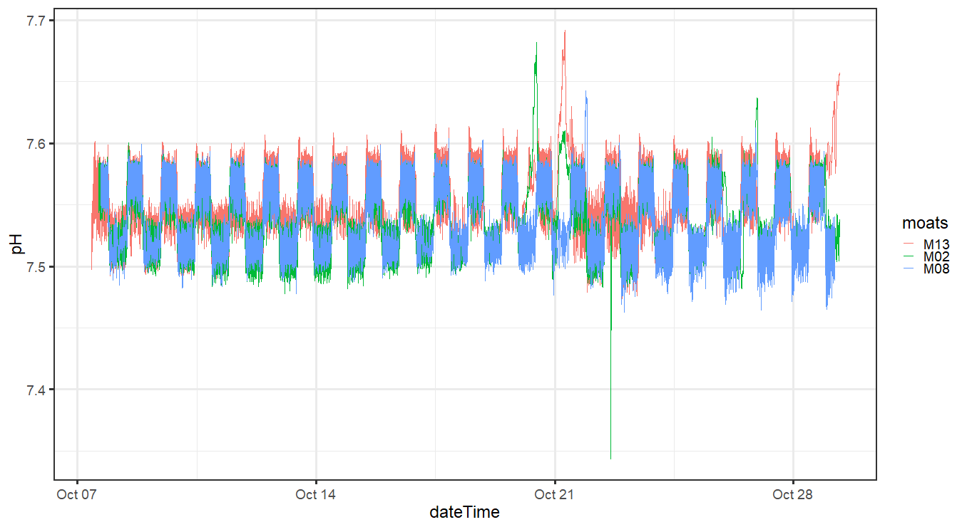

**Figure 5.1.3e “Winter Storm Event” Temperature Impacts- pH (MOATs 13, 08, 02)**

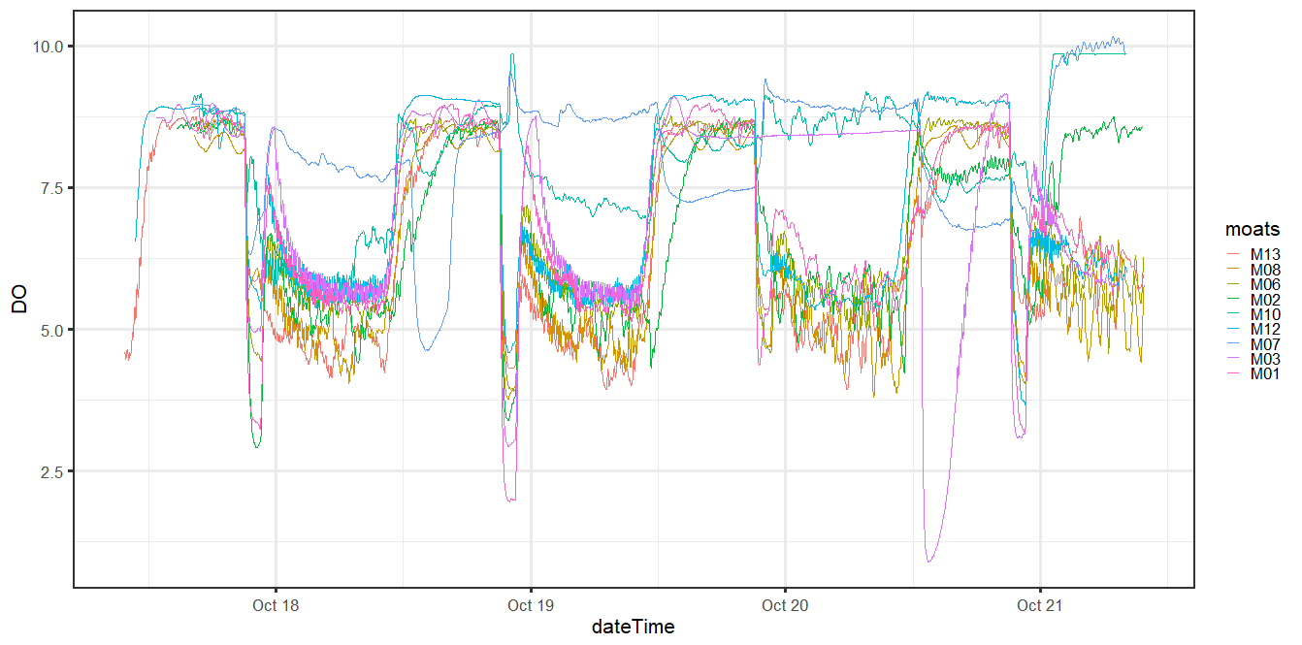

**Figure 5.1.3f “Winter Storm Event” Temperature Impacts- DO**

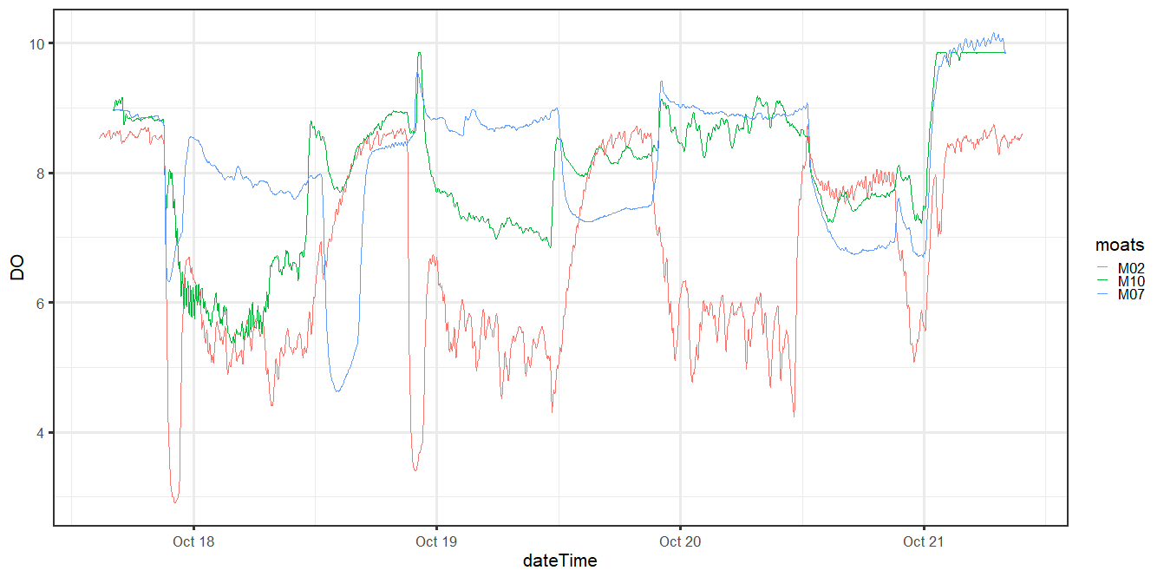

**Figure 5.1.3f “Winter Storm Event” Temperature Impacts- DO (MOATs 02, 07, 10)**

**22SEP19** SPOT was calibrated, 2 meetings went over the Krill end of experiment process and call was made to push out the experiment to 28-29SEP19.

Krill fed per routine

**23SEP19** barcodes printed, small pilot study accomplished with MOATs 11 krill to determine best process to accomplish respiration trial(s) inside the water bath and generate data to apply to respirometry code. 232.873 microMOL/liter is the approximate 80% DO oxygen threshold for Summer Study Krill.

Krill fed per routine

**24SEP19** changing the loading plan, draft 2 for new dates and helpful additions to sampling sheet.

Krill sampled and fed per routine.

**25SEP19**

Kill not fed per routine. Krill undergoing respirometry trial 1, day 1 were given a half shot of artemia. MOATs included 2, (3), 4, 6, 8, and 12. “Full Shot” MOATs included 1, 5, 7, 10, 11, and 13.  All krill were given the full amount of Instant Algae Solution. MOATs 03 is determined to be dropped from the study with MOATs 07 questionable.

Respirometry code is updated. In order to receive the most timely respirometry curve back- the sensor IDs, barcodes need to match what is generated as the unique krill on the datasheet. Barcodes made on 23SEP19 were then though to be “obsolete”. Any change between the loading location, location order, MOATs origin would need an updated sensor name and new barcode. If these were going to be sequential all the barcodes needed to be re-printed.

**26OCT19**- Krill fed per routine

**27OCT19** MOATs 1, 5, 7, 10, 11, and 13 fed per routine

MOATs 2, (3), 4, 6, 8, and 12 were not fed and EZ larva and Artemia cysts remained were siphoned away/vacuumed out.

**28-30OCT19** were the last three days of the experiment. Bulk of the work happened between 28-29OCT19.

1. **Respirometry**

**6.1.1 Respirometry goals**. The goal is to do respirometry on 15-20 krill per treatment, for a total of 45-60 krill.  The exact number depends on the size of the animals we are working with. Ensure at least two blanks per round of respirometry. Each round of respirometry for the Summer Experiment included 19 vials with 2 blanks.

**6.1.2 Respirometry Process Utilized, Explained**. 28OCT19 MOATs 1, 5, 7, 10, 11, and 13 not fed and EZ larva and Artemia cysts remained were siphoned away/vacuumed out. DO samples were taken between 0830-0930 samples showed levels were not achieving treatment particulars but remained around 75-80% dissolved oxygen. Determined that the loading plan would be determined on the day - first draft of barcodes matched the krill datasheet for telson length and wet weight. Allowed to have MOATs 12 replace MOATs 3 and would be present in both rounds of respirometry.

Sensor selection error occurred when testing the barcodes prior to the first respirometry round. Barcode names determined to be too similar and determined to be the cause of the issue. Reprinting the barcodes delayed the start of the respirometry trial by 45minutes to generate, print, and test scan all numbers. This second draft of barcodes no longer matched Krill IDs, respirometry code would should the general trend of the plots but remains incomplete while not linked to krill biometrics. All old barcodes, sensors deleted.

SPECs were forgotten in the water bath from the top of the day. While shifting between the lipids preparation spreadsheets MOATs 08 and MOATs 12 were over counted. The corresponding 8 vials, 4 from each MOATs was not attained. Krill were taken on 29OCT. Hours fasting was added to the krill collection datasheets both those spreadsheets included for respirometry and those only be prepared for lipids analysis.  Suggest that the minimum number of people working to end the experiment would be four people. Two people stay on lipids and two people stay on respirometry. It became difficult on the second respirometry round to “keep the thread on lipids” and change gears every 15minutes.

Barcodes for the second batch were not printed/generated until the end of the first round. Loading began on the second trial with only one person and without jars already filled with source water. This lead to a longer loading time.

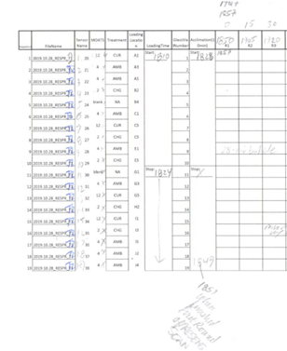

**Figure 6.1.1a Respirometry Loading Times**

29OCT19 MOATs 13 pump and chiller kicked offline due rounding experienced on the individual GFCI outlet for MOATs 13.  MOATS 7 was determined to remain as part of the study and the loading plan was changed for the final version.

Programmed settings for the first trial on Day 2 of Respirometry, Trial 3 of 4 overall, were not verified. Temperature defaulted to the last manually entered temperature of 14°C from conducting DO samples on MOATs 05 earlier that morning to get a final reading. Data remains un-transformed as  of 2019.11.07

**6.1.3 Barcode Management.** Good barcode management ensures creating unique SENSOR ID numbers. Think of sensors with a parent/child relationship. You create a master or parent sensor that will contain all the child sensor data when the researcher is asked to duplicate the sensor, Those new “child” sensors are indexed inside the “parent sensor”. When taking individual respirometry rates for different animals cycle through the different child sensors with the barcode reader. If any “Parent Sensor” name is to close to another Parent or Child Sensor this can cause selection errors while cycling through options on the Sensor. Be as unique as possible with names and conduct sensor audits often. One sensor called “Krill-001-19” seemed to be linked to more than one calibration and caused a cascade of problems for the first respirometry trial on day 1.

* + 1. **Creating barcodes:**

1. Connect PreSens to laptop using USB connection.
2. Open PreSens Datamanager on computer desktop.
3. Datamanager will show calibration files under “Sensors” tab and data files under “Measurements” tab. The Database display to the left shows files on the computer, and the Device display to the right shows data from the PreSens Fibox:

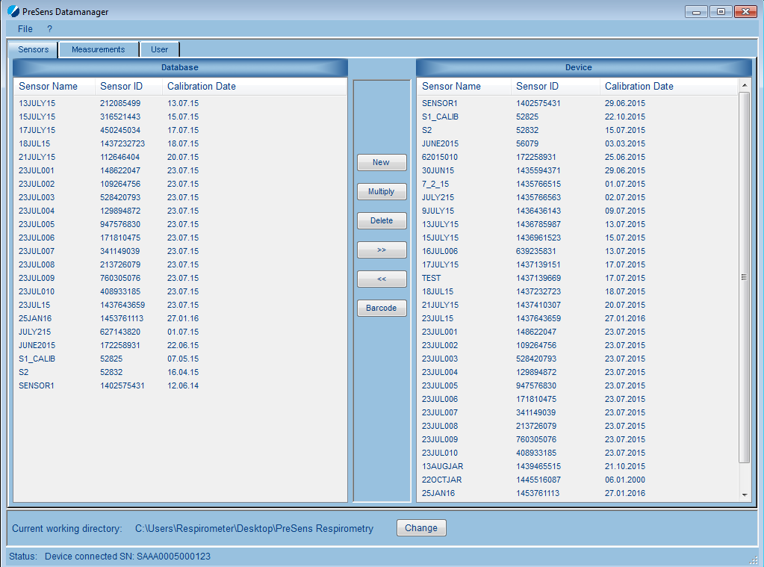

1. Select the most recent calibration file under “Device” and click [] to copy the file to the database.
2. Select the same calibration file under “Database” and click []
3. Enter ## under Quantity and click OK.
4. Program will duplicate sensor files, renaming them from 001-010. Click Finish.
5. Copy the duplicated sensor files over to the PreSens by selecting them and clicking [ 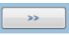]

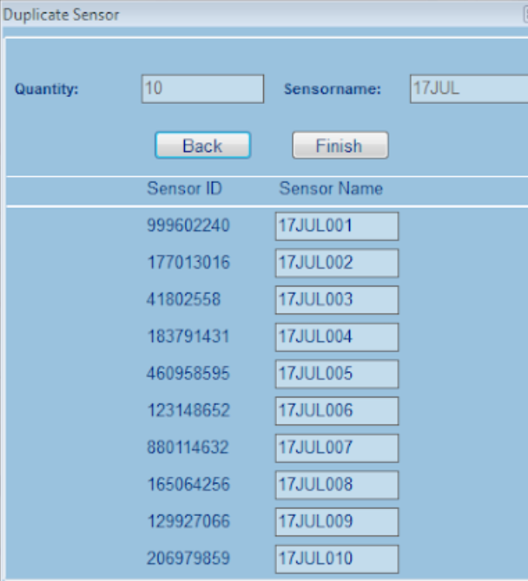

1. Select the ## new files in the Database and click []
2. QR codes will be generated for each of the files
3. Click Save and store the file as a PDF on the respirometry laptop (e.g., 17July15.pdf).
4. Open the pdf and print 2 copies on “Write-in-the-Rain” paper.
5. Put the QR codes out and attach them to the wall individually using tape.
6. Test barcodes with an initial scan but don’t start logging.
   * 1. **Settings on the PRESENS.** Steps below:
7. Turn the PreSens on. Press the back arrow button (top right) and select Meas. Settings

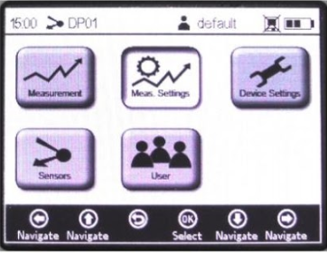

1. Under Temperature, select Manual. Use the arrow keys to set the temperature at 11° C.

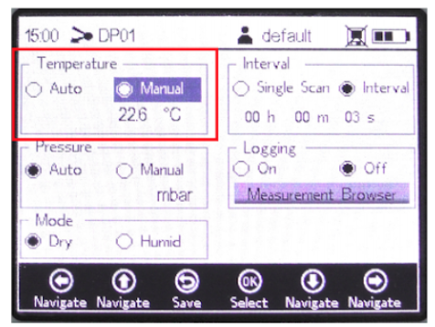

1. Under Pressure, select Manual and change the value to 1 atm.
2. Under Mode, select Humid.
3. Change the salinity to the appropriate daily value as measured with the salinity probe.  
   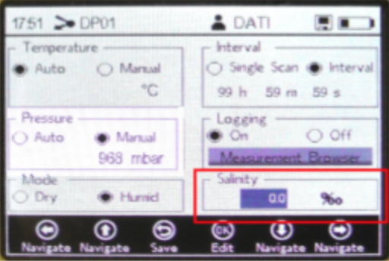
4. Under Logging, select On.
5. Under Logging, select Measurement Browser.
6. Create a new file for each trial (file label should be date and trial number).
7. Select the new measurement file and press OK.
8. Hit the back button to return to the main screen.
9. Return to the Measurement screen and hit the down arrow to change the measurement unit to mg/L (the units used in all four respirometry trials)
10. Make sure to record the date and file name for each trial (use premade data sheet).

**The four respirometry trials had the four following names:**

“Parent Sensor” KRILLR1_10_28_2019 built off calibration 22OCT19

“Child Sensors” named KrilLR11 through KriLR119

“Parent Sensor”KRILL_R2_10_28_2019 built off calibration 22OCT19

“Child Sensors” named KriLR220 through KriLR238

“Parent Sensor”KRILL_R3_29_OCT_2019 built off calibration 22OCT19

“Child Sensors” named KRLr3_39  through KRLr3_57

“Parent Sensor”KRILL_R4_OCT_29_2019 built off calibration 22OCT19

“Child Sensors” named KrilLR11 through KriLR119

**6.2.1 Transferring krill for respirometry**: Check to make sure that vials and vial caps are labelled with a number. If labels are faint, relabel vials with a black sharpie.

**Step 0:** A Krill Loading Plate- or Respirometry rack and water bath was used in lieu of chambers to keep vials at temperature. The Respirometry Rack has 50 available slots labeled in an Alpha-Numeric pattern starting with A-1 (Alpha-One) and proceeds to J-5 (Juliet-five). Spaces were left “open” between vials to allow circulation and a large center portion was left open to accommodate the large, red center weight.

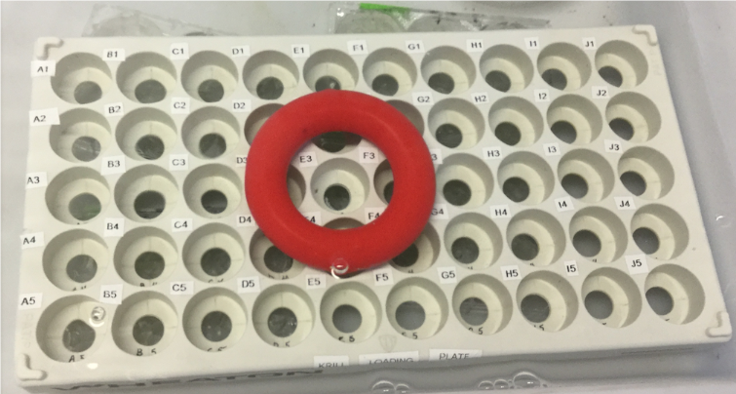

**Figure 6.2.1a Loading Plate/ Transfer Rack**

1. It is easiest to have more than one person working on this process. Set up jars of source water, filled vials (blanks and vials for incubations), and krill jars (in this order) on the table before krill transfer.

1.a) (3x) 2Liter Jars were filled with MOATs 12 water.

1.b) 250mL Krill holding jars will filled with MOATs 12 water

1.c) 250mL jars were labeled with the vial number that corresponded to the vial the krill would ultimately be transferred into for respirometry.

1. d) Krill were “spooned” out of the MOATs one at a time into the 250mL in order of the datasheet.

1.e) 250mL jars not currently being loaded with krill and those already loaded were placed in the water bath to remain at temperature rather than remaining on the counter.

1.f) The transfer basin was given approximately 2inches of MOATs 12 water to catch any krill “interrupted” in the transfer process. The transfer basin’s reservoir was there to catch any krill that jumped out.

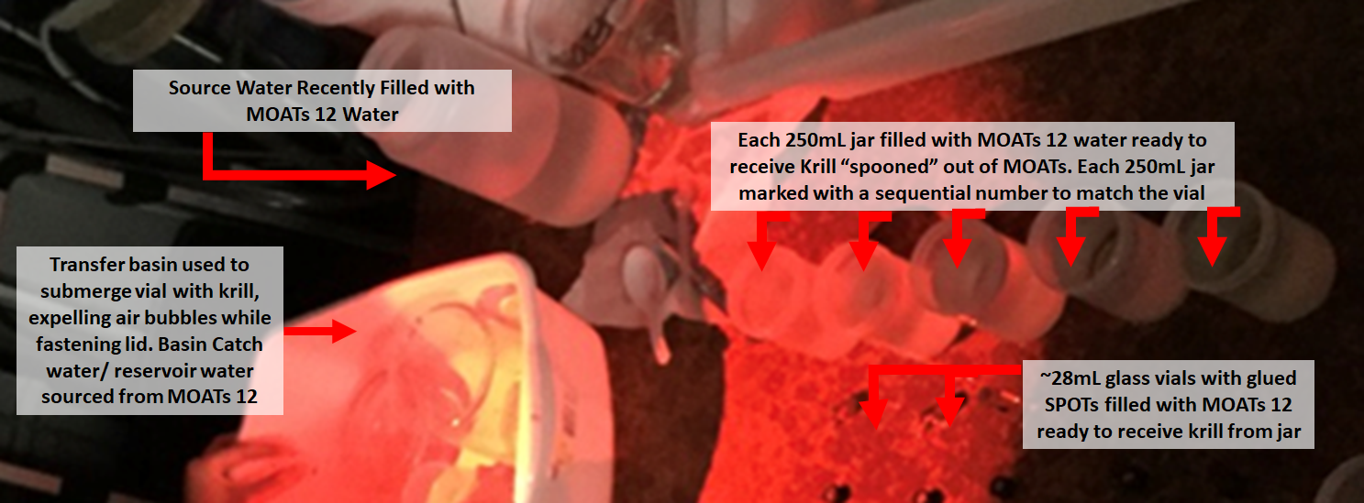

**Figure 6.2.1b Loading Set Up**

1. Make sure to record the time elapsed between the start of the first krill transfer and the time at which all vials in the trial have been measured. Create a map for the trial: which vials will be blanks, the source water for each vial, the krill in the trial and which vials each will occupy.  To do so, work with a document from the experiment that helps make sure that the krill and blanks from each MOAT are moved around the respirometry vials (prevents pseudoreplication).

2. a) Krill loading time was recorded from when the first Krill was loaded from the jar to the glass vial with the spot.

2.b) Loading plans were generated per the Krill Doctrine

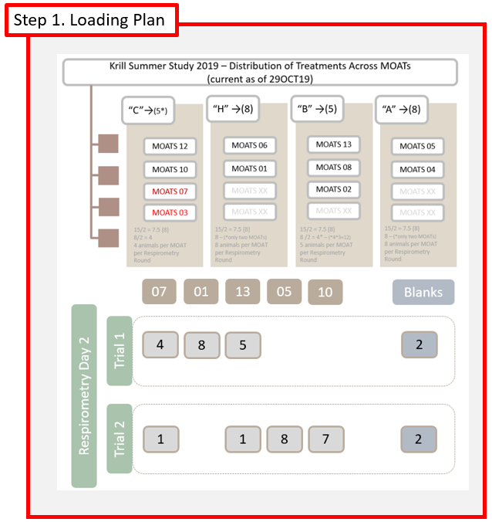

**Figure 6.2.1b Loading from The Loading Plan- Adaptions Made**

2.c) The loading plan examined is Respirometry Day 2, Trial 2.

Note the number of blanks and animals for round 2. Note that MOATs 07 was “under-sampled” due to its diurnal problems recorded between 21-29OCT19, and MOATs 10 was given the lion’s share of “current conditions” treatment animal slots.

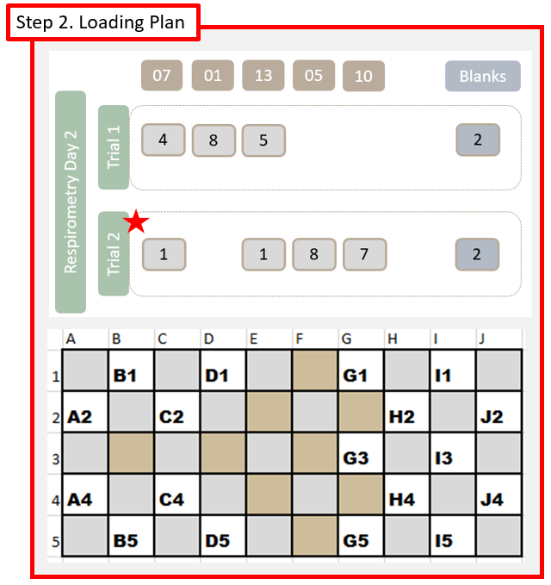

**Figure 6.2.1c Adapted Loading Plan with Alpha Numeric Locations**

2.d) Each animal called out in the loading plan in Step 2 would need to be associated with a spatial reference on the Respirometry Rack.

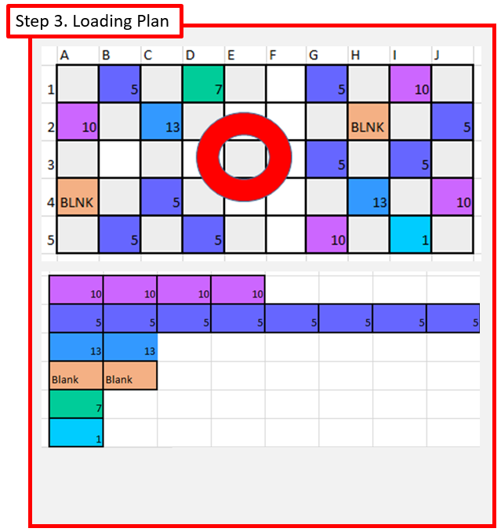

**Figure 6.2.1d Alpha Numeric Locations with Requisite Number of Animals**

2.e) Following the loading plan’s count of animals per MOATs, per treatment; match a krill to location (A-2, G5, etc.) to complete the loading plan with “Respirometry Channel Numbers” / Barcode identifiers.

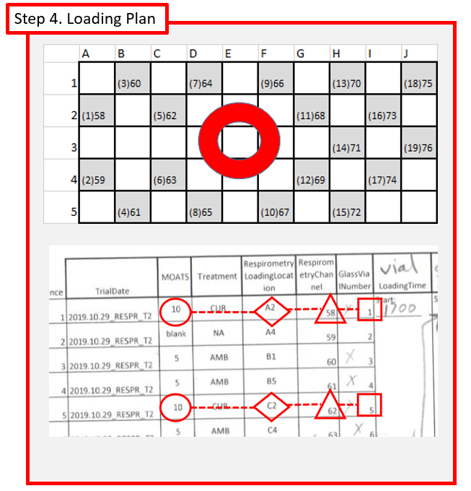

**Figure 6.2.1e Respirometry Datasheet Explained**

2.f) The printed loading plan for the researcher needs to include the MOATs to take the krill from to first place in the 250mL jar, the  Alpha-Numeric loading location, the barcode number/sensor number, and the glass vial number the krill will spend inside during the respirometry trial. These are indicated in the picture above with circles, diamonds, triangles and squares.

1. Set up jars of source water in front of vials in the correct order.
2. Pre-Fill vials with the appropriate source water using the blue tube (intermediate flow). Also prefill the 1 liter open container to perform a two-handed “vial dunk” while capping the glass vial.
3. Remove krill from system per the loading plan.
4. Once all krill are in the 250mL jars inside the water bath, begin loading into glass vials with spots. Record the start time for the procedure (start the stopwatch at start of krill transfer).
5. Spoon the krill into the glass vial, with the vial submerge thread the conical cap into place after air bubbles are allowed to escape. Two people are loading at a time.
6. Repeat steps 6-7  as needed for all vials/krill, loading the vials to their appropriate alpha-numeric location.
7. Record the start time (when last vial was measured) and load time (#min. between start of krill transfer and trial start time) for each trial.
8. Using the start time, figure out the times at which measurements should be taken and when vials should be inverted (every 15 minutes after a 10minute acclimation period).

**6.2.0 Cleanup tasks:**

1. Rinse the vials with deionized water.
2. Store the inverted vials and uncapped jar (from calibration) for drying in a closed drawer since the spots are light-sensitive.

Download data from the day’s trials from the PreSens to the laptop, and from the laptop to the Google drive.

**7.0 Lipid Analysis:**

**7.1.1 Lipid Analysis Goal.** All surfaces that the krill will contact, including tweezers and weighing vessels, need to be cleaned prior to krill collection. Gloves must be worn for sample collection, and everyone doing collection should refrain from using lotions immediately prior to krill collection. Each krill will be rinsed in filtered seawater, patted dry with a Kim Wipe, and weighed. (Note that each krill will also be IDed to species and sex, and photographed for measurement of telson.)  Krill from each replicate will be grouped so that the group mass of each composite sample is 100mg or greater. Keep detailed records of the gender, length, and mass of each individual in each composite sample. Each composite sample will be frozen in a cryovial using liquid nitrogen and kept at -80⁰C. FOUR lipid samples should be collected from each MOAT. Any krill remaining after the lipid sample collection should be weighed, measured for size (telson), sexed, species IDed, and frozen at -80⁰C in a single vial for each MOAT.

**7.1.1 Lipid Analysis Procedures Utilized.** The following steps outline how the specimens were prepared .

1. Clean all surfaces that krill will come into contact
2. surfaces including weigh boats will be cleaned in a 10% liquinox rinse, a filtered fresh water rinse, followed by a 95% ethanol rinse, followed by another  filtered fresh water rinse. Pat dry with kim wipes.
3. Gloves are to be worn for sample collection, anyone doing collection should refrain from using lotions immediately prior to krill collection.

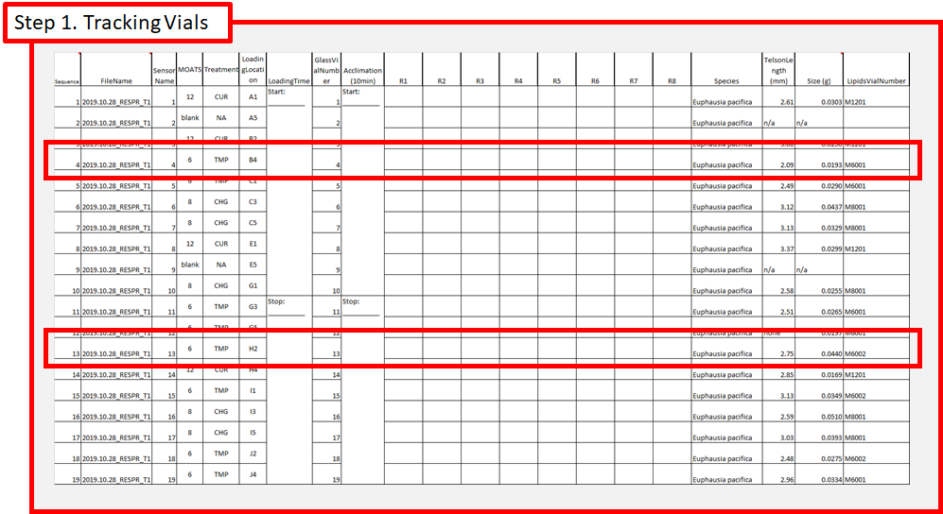

**Figure 7.1.1a Tracking Vials through the Respirometry Sheet**

Notice the example for MOATs 06 animals. Contained inside the respirometry datasheet are the particulars regarded for follow on lipids analysis.

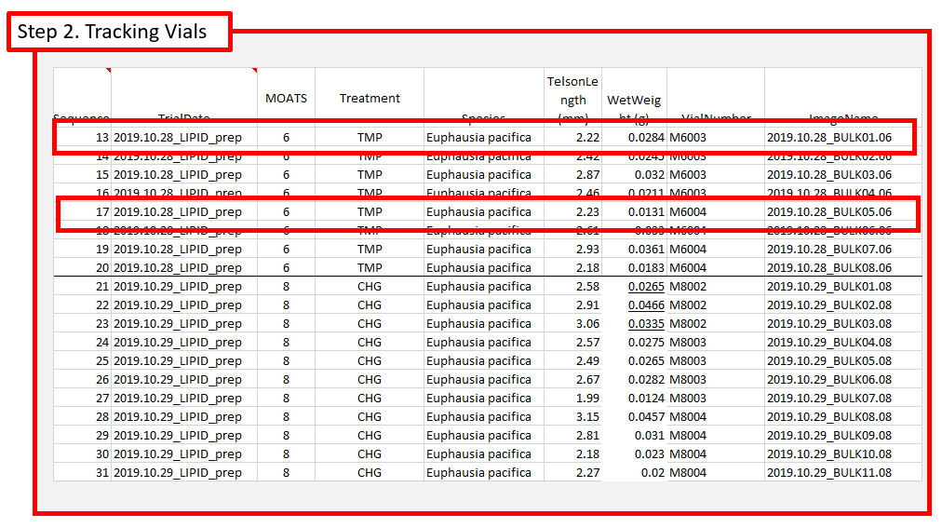

**Figure 7.1.1b Tracking Vials through the Lipids Sheet**

Another datasheet contained information collected from krill processed for follow on lipids analysis between and after rounds of respirometry.

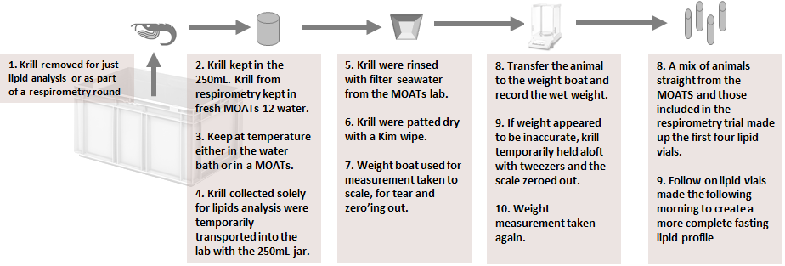

**Figure 7.1.1c Processing Krill for Lipids**

1. Remove krill from the MOATs to either go directly on for lipids analysis preparation or first include with a respirometry trial.

1. Store the krill in a 250mL jar with fresh filtered sea water. If not immediately processing the krill for lipids analysis keep the animal and jar at temperature via means of the respirometry water bath or use a “closed-out” MOATs to stand-in as a water bath. Ensure that krill from a respirometry vial go into a 250mL jar labeled with their glass vial number or respirometry channel number, or barcode number.

1. When krill are ready to be ultimately processed for lipids analysis, rinse with filtered sea water.

1. Select a weigh boat and take to the scale to tear and zero out.

1. Place krill on weighed boat. Use a kim wipe to “dehydrate” the krill as best able and remove any excess water.
2. Weight the krill, record weight
3. ID the krill species
4. Capture a photo of the krill’s telson, and record measurement with IC Measure software.
5. Capture a picture of the head for records keeping on species identification with IC Capture software.
6. Place the krill inside a cryovial for subsequent flash freezing in the -80°C freezer
7. Record the wet weight while tallying the total biomass contained inside the present cryovial. Once 100mg is achieved move the vial. Serialize the vial with a label with the following convention:

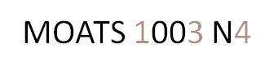

**Figure 7.1.1c Lipids Label Convention**

1- refers to the MOATs Number

3- refers to the sequence number of the cyrovials, usually 1-4

4- refers to the number of krill inside the vial usually being 3-5krill making up 100mg

**Treatments:**

Flow rate: 50 minutes for a moat turnover for a 44 L MOAT. About 50 ml/3.85 seconds. This is from the krill husbandry calculations google doc sheet under flow rate.

Day conditions (13.5 hr)→ 1.5 hr ramp to night conditions → Flow off for night (7.5 hr) → 1.5 hr ramp to day conditions

|  |  |  |  |  |  |  |  |  |
| --- | --- | --- | --- | --- | --- | --- | --- | --- |
|  | **Temp** | **pH** | **DO** | **salinity** | **alkalinity** | **pCO2** | **Hconc** | **% Sat DO** |
| Acclimation | 110 | 7.73 | 9.4 | 29.3 | 1997.615 | 798.8425 | 18.62087 | 100 |
| CurrentDay | 110 | 7.64 | 5.6 | 29.3 | 1997.615 | 995.2630 | 22.90868 | 60 |
| CurrentNight | 121 | 7.73 | 9.2 | 29.3 | 1997.615 | 802.7367 | 18.62087 | 100 |
| HighTempDay | 132 | 7.5640 | 5.4 | 29.3 | 1997.615 | 1411.3284 | 31.62278 | 60 |
| HighTempNight | 143 | 7.7357 | 8.8 | 29.3 | 1997.615 | 1198.4801 | 26.91535 | 100 |
| AllChangeDay | 132 | 7.50 | 4.5 | 29.3 | 1997.615 | 1411.3284 | 31.62278 | 50 |
| AllChangeNight | 143 | 7.57 | 8.8 | 29.3 | 1997.615 | 1198.4801 | 26.91535 | 100 |

Modern conditions based on Reum et al 2014, 2016

Future conditions based on Khangaonkar et al 2019